SNC Routine Start-shot Test

# Purpose

This procedure lists the steps involved in performing starshot tests for gantry, couch, collimator, and MLC on Elekta. The starshot test verifies coincidence of beams shot at different angles.

# Steps

1. Log on to SNC PC at linac using username *onc1* and blank password.
2. Start linac in Clinical Mode. Warm up if necessary.
3. Prep linac.
   1. Use control panel to move couch out of the way.
   2. Remove couch extension.

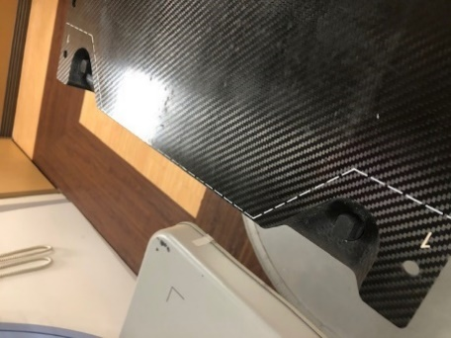

1. Open XVI on XVI computer, if necessary.
   1. Double-click XVI icon on Desktop.
   2. Log in to XVI in Service Mode.
      1. Enter username *service2*. (Password is blank.)
      2. Select the *Service* radio button.
      3. Click *OK*.
   3. Use Ctrl+Shift+Tab to switch to iView. (iView images automatically go to MOSAIQ.)
2. Log in to MOSAIQ, if necessary.
3. Load **ZZZ_SNC, SNC MACHINE E-1** (if on E-1) or **ZZZ_SNC E-2** (if on E-2).
4. Prepare iView to receive image.
   1. Open patient **ZZZ_SNC, SNC MACHINE E-1** (if on E-1) or **ZZZ_SNC E-2** (if on E-2).
   2. Click Site **Site1**.
   3. Click Field **SST01**.
   4. Click **iCOM** icon.
5. Run linac beam.
   1. Select **RO Treat**.
   2. Click **QA Mode**.
   3. Click *Yes*.
   4. Click *Continue*.
   5. Highlight field **SST01** and click *Select*.
   6. Click *OK*.
   7. Use ASU buttons on linac console to adjust gantry and collimator.
   8. Press the green MV button on the linac console to deliver beam.
   9. When beam finishes, click *Record*.
6. Repeat steps (7c)–(8i) for fields **SST02**, **SST03**, and **SST04**.
7. Click **Done** icon.

**Note:** SNC Routine [steps (11) and (12)] are not necessary if you are just doing the Hancock-Winston-Lutz (HWL). However, Routine can be used in this case if you want to see results immediately.

1. Open SNC Routine.
   1. Double-click **PDI Host** icon on SNC PC Desktop.
   2. Double-click **SNC Routine** icon and login with username ? and password ?.
2. Images and results are automatically generated under “Machine Tasks: Due” on the SNC Routine dashboard for the date generated. Review test results.
3. Reattach couch extension.
4. Retract MV panel, if needed.